TITLE OF PAPER
(TWO LINES AT THE MOST)
1st Given Name Surname, Name of organization (Affiliation), e-mail
2nd Given Name Surname, Name of organization (Affiliation), e-mail

Abstract: In the abstract, briefly present the basic idea and the achieved results. Write the paper based on the text from this instruction. An abstract can contain up to 200 words.

Keywords: Maximum of five keywords or phrases, separated by commas.

1. INTRODUCTION

The paper should have a clearly given introduction, problem statement, solution, results, conclusion and literature. The paper is submitted to the Program Committee of the Conference in electronic form in PDF format. The paper is limited to six pages including figures, tables, references. On the pages of the work, the margins must be: upper and lower 2.5 cm, left and right 2 cm. Pages do not need to be numbered. The title of the paper should be in the middle of the first page shifted by two 10pt spacing below the top margin.

2. HEADLINE

Below the headline (Times New Roman, all capital letters, size 12 pt) list the authors in separate lines, font size 10 pt. After the names of all authors, leave two blank lines of size 10 pt. The rest of the test must be written in Times New Roman font and size 10 pt, in two columns, 5 mm apart, as shown in this example.

Use text alignment "justified", except when specifying references where left alignment should be used. Write the abstract and keywords in italics. Number the subheadings, except for the entire reference. Use capital bold letters.

There should be one blank line of 10 pt before each paragraph, and no text should be indented at the beginning of the paragraph. If the last page of text is not filled, reduce the columns on that page to the same length.

2.1 Heading Level 2

INFOTECH Conference Proceedings will be available on Web site.
4. CONCLUSION

Tables and figures can be wider than one column. Above the table should be an inscription, e.g. "Table 1. Influence of blocking factors". Below the picture should be the number of the picture and the legend, e.g. "Figure 3. Two-way communication ERP and VBS.". For images, use a resolution of 600 dpi for monochrome and 400 dpi for color. Use the "insert picture from file" option.

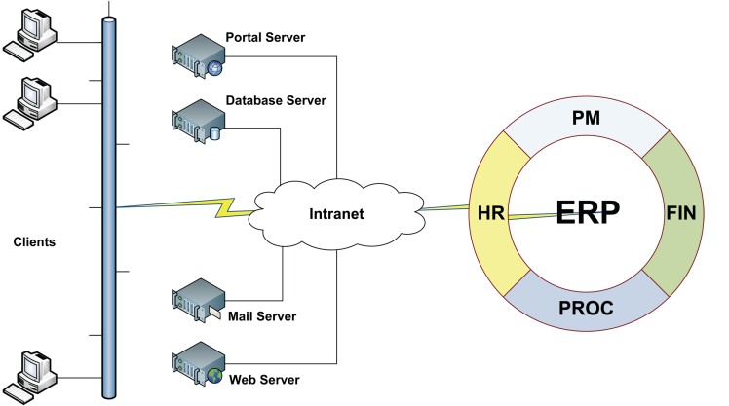
Figure 3. Two-way communication ERP and VBS.

In addition to the formulas, the ordinal number of the formula should be given in parentheses as code (1), aligned to the right.

$$f\left(x\right)=a_{0}+\sum_{n=1}^{∞}{\left(a_{n}\cos{\frac{nπx}{L}}+b_{n}\sin{\frac{nπx}{L}}\right)}$$ | (1)

References to other papers are made by quoting the ordinal number of the reference in square brackets. For example, in [2] it is shown ... References are given at the end, in the order of appearance.

REFERENCES

[1] V. Pantović, M. Savković, D. Starčević, "The Role of Portal Technologies in Corporate Lifelong Learning System", Proc. IASTED Computers and Advanced Technology in Education Conference, Lima, Peru, 2006.
...

[5] J. M. Spivez, The Z Notation, Prentice Hall, 1992.

